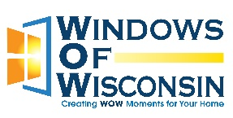
Job Posting: Brand Ambassador
Need part-time, but not SO part-time that you don’t make decent money? Oh! AND, don’t you just want to spend your entire shift talking to people without your boss telling you to stop talking to everybody??
Yeah. We get you. Windows of Wisconsin is where you should apply next.
What you’ll be doing:
Actively engaging with customers at a large, busy retail location in Green Bay providing them information about the windows we sell to schedule appointments with our sales team.
DOESN’T THAT SOUND…SIMPLE, YET AMAZING?!!
Why you’d be interested in this job:
- Income potential! Earn a base wage of $18/hr PLUS the potential for a $50 bonus PER appointment that customers keep with our sales team! Now THAT’S a part-time gig!
- Flexibility! The hours we’re looking to staff for fall mid-mornings to early evenings. What works best for you??
- Paid training! We will set you up with all of the knowledge you’ll need to be successful. And you’ll make your hourly wage while training!
- You’re potentially a good fit if:
- You’re outgoing, empathetic, and willing to actively engage with the public on a consistent basis
- You are hungry for those bonuses!
- You’re at least 18 years old with reliable transportation
Windows of Wisconsin is located in Kaukauna, WI, visible from Highway 41 on the frontage road. We’re the company with the blue and silver sparkly tree out front! Carl Hardtke has owned and operated our company since 1997. With our local team of business experts and craftspeople, we are excited to offer this unique opportunity to join the WoW experience. Feel free to check out our website at www.windowsofwisconsin.com!
EOE employer

