
Wisconsin Moving from NEC 2017 to NEC 2023
Effective September 1, 2026

The below are the main changes that will affect Residential Home Builders in WI; ensure you talk to your local AHJs and codebooks to make sure you are installing/wiring per code.

2023 Wisconsin Code Update – Main Changes Impacting Residential Construction
- Meter-main disconnects NEC 230.85: meter-main emergency disconnects are not required for a single-family residence served by its own individual meter.
- Whole-house surge protection NEC 230.67: Wisconsin keeps the requirement for Type 1 or Type 2 surge protective devices on dwelling unit services.
  - Surge protection locations: SPDs must be installed as part of the main service equipment or immediately adjacent to it, unless installed at the next level of distribution equipment downstream.
  - Surge protection triggers: Required for new residential construction and for service replacements or upgrades.
- Kitchen island and peninsula receptacles 2023 NEC 210.52(C): Wisconsin requires at least one receptacle on qualifying island and peninsula countertop spaces, rather than making them optional. (Can either mount on top or side of island)
  - Island receptacle size threshold: Requirement applies where the countertop space is at least 24 inches long and 12 inches wide.
  - Island receptacle mounting: Wisconsin allows receptacles to be mounted up to 12 inches below the countertop on the cabinet side if specific conditions are met.
- GFCI appliance rollback 2023 NEC 210.8(D): Wisconsin does not adopt several GFCI requirements for appliances such as electric ranges, wall ovens, microwaves, and hydromassage bathtub circuits.
- Outdoor equipment GFCI rollback 2023 NEC 210.8(F): Wisconsin does not adopt the GFCI requirement for outdoor hardwired equipment such as HVAC condenser units.
- Basement GFCI scope 2023 NEC 210.8(A)(5): Wisconsin limits required basement GFCI protection mainly to unfinished basement areas, rather than all basement spaces.
- AFCI retrofit rollback NEC 210.12(E): Wisconsin does not require AFCI protection to be added when existing residential branch circuits are modified, extended, or replaced.

These changes should be an overall net benefit for the Wisconsin Builders. There is minimal cost for the Surge Devices with good reward (<$500 depending on type, MFG and Install). Many vendors have tools to help show the benefit (Eaton-Home-Surge-Infographic-SI-v3) and offer a warranty for the devices as seen below.
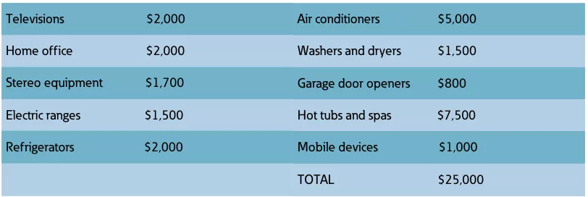
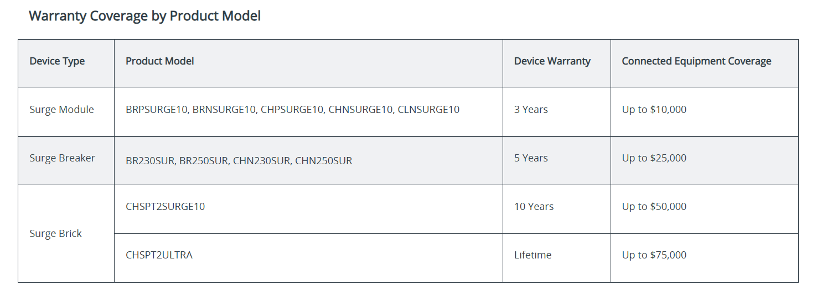

With the deleting of 230.85 – this change is substantial as it was going to increase the cost of a 200 Amp meter ped by approximately $700 just in Material. With WI not forcing the installation of Countertop pop-ups on Islands – that also saves anywhere from $150-400 in materials alone. There will also be cost savings realized with the rollbacks of GFCI and AFCI breakers that WI DSPS chose to do.

