A Coronavirus Update from Rep. Gallagher

As we continue to combat the coronavirus outbreak, I view one of my primary roles as being source of reliable information to Northeast Wisconsin. Below I am including a number of resources that I hope give you a better understanding of the coronavirus response at the federal, state, and local level.

In the Marines we used to say "Prepare for the worst, hope for the best." And in times like these, one of the best ways to prepare is to stay informed. Knowledge is power, and as the situation continues to develop, I encourage everyone to stay up to date on all the latest news both nationally and locally.

It will take a joint effort from all levels of government in partnership with our hospitals to prepare aggressively while avoiding panic. But rest assured that based off my conversations with hospitals throughout Northeast Wisconsin, and state officials like Governor Evers, I'm confident we have all hands on deck in working to ensure Wisconsin is best prepared to combat the coronavirus.

I hope you find these resources useful. Please don't hesitate to reach out to my office if we can be helpful.

Semper Fi,
---------------------------------------------------------------------------------------------------------------------
What You Need to Know About Coronavirus

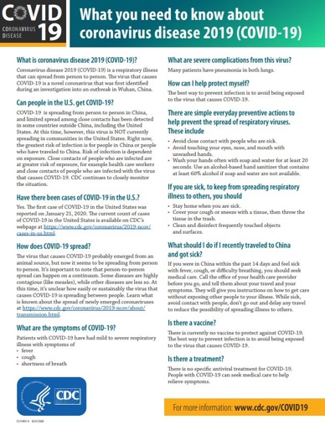

The document above from the Centers for Disease Control and Prevention (CDC) provides a strong overview of the coronavirus. Click HERE to also visit the CDC's website for more information on the virus.
-------------------------------------------------------------------------------------------------------------------
Wisconsin Specific Information

Keep up to date with the latest coronavirus updates in Wisconsin by following the Wisconsin Department of Health Service's live report on outbreaks in Wisconsin.

You can also monitor the websites of your County Health Officials. Below are links to each of the County Health Offices' websites in Wisconsin's Eighth District:
· Brown County
· Calumet County
· Door County
· Kewaunee County
· Marinette County
· Menominee County
· Oconto County
· Outagamie County
· Shawano County
· Waupaca County
· Winnebago County

-------------------------------------------------------------------------------------------------------------------

Teletown Hall with WI DHS Deputy Secretary Julie Willems Van Dijk

Rep. Gallagher Holds Coronavirus Teletown With Wisconsin Health Official

On March 11, 2020, Rep. Gallagher hosted a coronavirus teletown hall with Wisconsin Department of Health Services Deputy Secretary Julie Willems Van Dijk to provide information and answer constituent questions on the outbreak. Listen to the full teletown hall HERE.

-------------------------------------------------------------------------------------------------------------------

Federal Actions Taken

On March 4, the House passed a more than $8 billion emergency funding package that was quickly passed by the Senate and signed into law by President Trump. It was also recently announced that of the nearly $700 million going to state and local efforts from the CDC, Wisconsin will be receiving over $10 million to help our officials with the response. This is in addition to the initial $1 million Wisconsin received earlier.

But make no mistake, the federal government should continue to aggressively act. The FDA recently announced eligible private labs to conduct testing, therefore expanding testing capabilities at the state level. The FDA and CDC are also working quickly to approve new testing methods to help mitigate these concerns and continuously releasing guidances on mask and respirator use to ensure that our healthcare professionals have access to the highest grade protectants.

Please monitor my website and Coronavirus Page for more updates on our federal response
------------------------------------------------------------------------------------------------------------------

Additional Resources

You may also find the resources below to be helpful. And if you have questions, please don't hesitate to reach out to my office.

· CDC Handwashing Guide
· Gov. Evers declares public health emergency due to COVID-19
· Wisconsin Department of Health Services Guidance on Mass Gatherings

‌

